**TECH WEB NEWS PAGE**

Assignment 1 - Technical Design Report

HCS504 – Web Development

LUKE

GILBERT



Table Of Contents

INTRODUCTION 1

UI/UX DESIGN 2

HTML STRUCTURE 3

Semantic HTML 4

CSS AND STYLING 5

CSS Selectors 6

Webpage Hosting on Server 7

CROSS PLATFORM ANALYSIS AND TESTING 8

CONCLUSION 9

References

APPENDIX A – PROJECT BRIEF

APPENDIX B – HTML FILES

APPENDIX C – CSS FILE

# INTRODUCTION

This technical design report has been prepared to demonstrate the rationale behind the design and implementation of a Tech News Web Page using HTML and CSS which is the main artefact to be produced for the assignment.

The report will cover the following aspects:

* UI/UX Design Considerations
* HTML Structure of Webpage
* CSS and Webpage Styling
* Hosting via. Student Web Server
* Cross Platform Analysis and Testing

Further detail of the main tasks undertaken as a part of this assignment can be viewed in the Appendix (Appendix A).

In addition to discussion of how these aspects have been implemented within the assignment, further rationale will be provided for each design choice.

A link to the working webpage can be found below:

https://mayar.abertay.ac.uk/~2307369/Assignment1/index.html

All images sourced from the page can be found at the link below:

https://unsplash.com/s/photos/technology?license=free

# UI/UX DESIGN

Initial design work was undertaken using the online design tool Figma. This exercise was undertaken to establish an initial design for the UI/UX to then be implemented using HTML and CSS. This stage was effective in allowing for creativity in the layout/design without the initial technical limitations of implementation.

Figure 2.1 - Initial Page Layout Designs and Hover Animations

Initial thoughts for the desgin were to highly feature the use of images on the home page rather than large blocks of text. This will not create intrigue for the users encouraging them to explore the page but makes the articles more memorable as the visuals tend to be more memorable (Pavio, 1973).

The initial design puts an emphasis into visual feedback for the user based on their interactions which elements on the page. Typically this is achieved through hover effects on elements which change based on their current active hover condition.

# HTML STRUCTURE

The structure of a HTML is an essential component to ensure that the content for the page is displayed correctly in the browser, this hopes to accomplish the aim of creating a positive experience for users. The structure not only determines the order in which elements will be rendered in the browser but can enhance users’ accessibility experience through using semantic HTML and providing additional information for screen readers.

The webpage’s HTML file can be viewed in the appendix (Appendix B).

Figure 3.1 - Extract of HTML w/ Semantic HTML Examples Highlighted

## Semantic HTML

The use of semantic HTML is demonstrated throughout allowing for a clear code structure which can be easily understood by future contributors. The use of this semantic HTML allows for increased accessibility for the page using screen readers which can interpret HTML elements based on their tags and relay the information back to the user.

The web page for which this technical report pertains to includes use of the following semantic HTML (Descriptions of each item can be found at www.w3schools.com):

* Head Tag <head>
* Body Tag <body>
* Footer Tag <footer>
* Article <article>
* Figure Tag <figure>
* Image Tag <img>
* List Tags <ol> / <ul>
* Header Tags <h1> / <h2>
* Anchor Tag <a>

In addition to the usage of sematic tags, the use of additional attributes for these elements has been utilised to further the accessibility and functionality.

These are as follows:

* href for <a> tags: Used to give a destination for the hyperlink to send the user to.
* src for <img> tags: Used to define a source for an image file to be displayed on the page.
* alt for <img> tags: Used to provide additional context for images, especially useful for screen readers.

# CSS AND STYLING

There are millions of different pages across the web all competing for the attention of users, one of the main ways you can set your webpage apart from the crowd is the styling using CSS as it can help to create a lasting first impression which can keep users coming back time and time again (WebFX, n.d.).

The Tech News Web Page uses a colour palette of three colours to try and keep the design simplistic and drive the focus to the news articles with their eye-catching visuals and headlines. There has been some effort made to include some interactivity on the page with user feedback given on various aspects when hovered by the user.

Large Images Draw Attention of Users to Interact. Images over text blocks to avoid information overload

Simplified use of colours to avoid over stimulation of users and draw attention to key areas

Reduced opacity on non-active page links to clearly indicate current page to user

Figure 4.1 - Key CSS Design Decisions Highlighted

The webpage’s CSS file can be viewed in the appendix (Appendix C).

## CSS Selectors

It is important here to discuss the selectors utilised in the CSS as there is a multitude that have been implemented to apply styles to different elements, each of which have vary in specificity in the selector hierarchy.

Below is a list of CSS selectors which have been utilised within the assignment with further information on these found on w3schools’ website (W3schools, 2019):

* Simple Selectors (element, id, class)
* Combinator Selectors
* Pseudo-class Selectors

Pseudo Selector

Combinator Selector

Simple Selector

Figure 4.2 - CSS Extract for Nav Highlighting Different Types of Selectors Used

# Webpage Hosting on Server

For this assignment the files for the webpage are hosted on the Abertay University Student server to make them able to access outside of a user running the files locally stored on their machine.

Figure 5.1 - Webpage Files Hosted on Student Server

# CROSS PLATFORM ANALYSIS AND TESTING

A key aspect in the modern age of the web is the ability to seamlessly display page content across all platforms. Though full responsiveness is not a requirement for this assignment an effort has been made to implement responsive design for the webpage.

One such way this has been implemented is using viewport units for the height and width of various page elements. Since these are directly linked to the size of the webpage these can shrink and grow to suit.

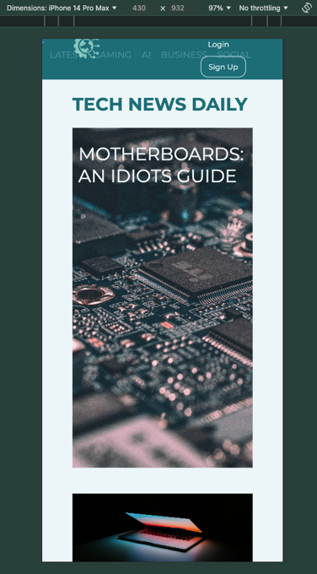

Figure 6.1 - Desktop vs. Mobile Webpage Views

As it can be seen above, using the viewport units effectively scales the elements on the page to suit the screen size, however it is noted that the navbar styling now looks a little squashed and out of place. Typically, this is solved through the implementation of so-called hamburger menu which appears as the screen shrinks and space becomes limited. The design could also look to shrink down any text to suit the screen size and take up less space.

# CONCLUSION

This report has detailed the main steps and design decisions taken for the development of a Tech News Web Page using CSS and HTML. It discussed the importance of the HTML structure, Semantic HTML and CSS in the development of this page and how the initial designs were implemented using these.

A brief look into how the webpage was hosted on the student server and the responsive design of the webpage was also discussed and suggestions of a hamburger menu and responsive font sizes were proposed for smaller screen sizes.

#### References

Csapo, K.G. and Paivio, A. (1972). Picture Superiority in Free Recall : Imagery Or Dual Coding. London [Ont] : Department of Psychology, University of Western Ontario.

W3schools (2019).CSS Selectors. [online] W3schools.com. Available at: https://www.w3schools.com/css/css_selectors.asp.

WebFX (n.d.). Why Is Web Design Important? | 6 Reasons to Invest in Site Design. [online] WebFX. Available at: https://www.webfx.com/web-design/learn/why-is-web-design-important/.

www.w3schools.com. (n.d.). HTML Reference. [online] Available at: https://www.w3schools.com/tags.

#### APPENDIX A – PROJECT BRIEF

#### APPENDIX B – HTML FILES

#### APPENDIX C – CSS FILE